**General Objective:**

Upon completion of this lab, the student will be able to:

1. Calculate voltages, currents, gains, and impedances of Push-Pull amplifier circuits.
2. Construct, measure, and demonstrate the proper use of the test equipment.

**References:**

* Theory notes
* First Year Text & Lab books

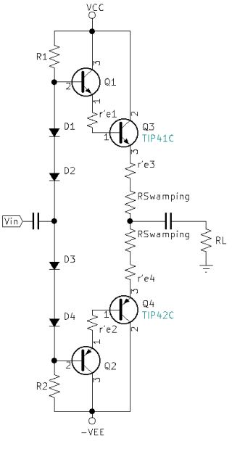**Check-Off Sheet:**

* [Check-Off Sheet](https://drive.google.com/file/d/1heioqV66_vxlIYQkZ_QA1aH_7t-7VXHj/view?usp=sharing)

**Specific Objectives:**

1. Push-Pull Amplifier
   1. Design a Push-Pull circuit to accept Vin from the variable gain Diff-Amp from your previous lab. Your Push-Pull will be designed to drive a 5-watt, 8-ohm speaker.
   2. Show all calculations.
   3. **Instructor Check**
   4. Using an equivalent load resistor, measure gain and frequency response of the amplifier.
   5. **Instructor Check**
   6. Functionally test the circuit using an instructor issued speaker
   7. **Instructor Check**
2. Complete Conclusion and submit completed Check-Off sheet and Lab writeup in Moodle.